SDM END MODULE EXAM
Name: sanket kulkarni
Prn: 250840320173
Email : sanket.kulkarni.cmaug25@gmail.com
1.1
import { useState } from 'react'
import reactLogo from './assets/react.svg'
import viteLogo from '/vite.svg'
import './App.css'

function App() {
const [count, setCount] = useState(0)

return (
<>
<div>
<hr>signup form</hr>
<form>
<div>
<label>username</label>
<input type ="text"/>
</div>
<div>
<label>email</label>
<input type ="email"/>
</div>
<div>
<label>password</label>
<input type ="password"/>
</div>
<button type="submit">signup</button>
</form>
</div>
</>
)
}

export default App
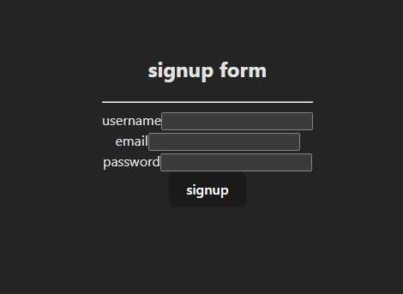
1.2
FROM NODE:18-alpine
WORKDIR /app
COPY package*.json ./
RUN npm install
COPY . .
EXPOSE 5174
CMD ["npm", "run", "dev"]
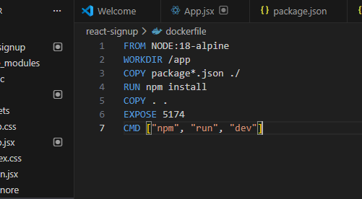
1.3
docker build -t signup-react:1.0 .
1.4
docker run -d -p 5174:5174 --name signup-container signup-react:1.0
docker ps
http://localhost:5174
1.5
docker tag signup-react:1.0 sankut/signup-react:1.0
docker push sankut/signup-react:1.0
https://hub.docker.com/r/sankut/signup-react
Q2
docker run -d --rm --name webapp-container -p 3000:80 mywebapp:v1
Q3
kubectl expose deployment nginx-deployment --type=LoadBalancer --port=80 --target-port=80
Q4
docker exec -it mysql mysql -u root -p

Q5
FactorialengineTest.java
package com.example.factorial;

import static org.junit.Assert.assertEquals;
import org.junit.Test;

public class FactorialEngineTest {

@Test
public void testFactorialOfFive() {
FactorialEngine engine = new FactorialEngine();
int result = engine.calculateFactorial(5);
assertEquals(120, result);
}

@Test
public void testFactorialOfZero() {
FactorialEngine engine = new FactorialEngine();
int result = engine.calculateFactorial(0);
assertEquals(1, result);
}

@Test(expected = IllegalArgumentException.class)
public void testFactorialOfNegativeNumber() {
FactorialEngine engine = new FactorialEngine();
engine.calculateFactorial(-4);
}
}
factorailEngine.java
package com.example.factorial;

public class FactorialEngine {

public int calculateFactorial(int number) {
if (number < 0) {
throw new IllegalArgumentException("Number must be non-negative");
}

int result = 1;
for (int i = 1; i <= number; i++) {
result *= i;
}
return result;
}
}
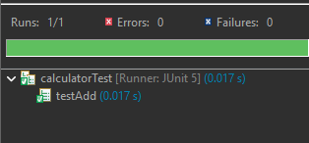
Q6
package selenium.selenium;

import org.openqa.selenium.By;
import org.openqa.selenium.WebDriver;
import org.openqa.selenium.edge.EdgeDriver;

public class demo {
public static void main(String[] args) {
System.setProperty( "webdriver.edge.driver" , "G:\\SANKET\\msedgedriver.exe");

WebDriver driver = new EdgeDriver();
driver.get("https://www.amazon.in/ap/signin?openid.pape.max_auth_age=0&openid.return_to=https%3A%2F%2Fwww.amazon.in%2Fgp%2Fhelp%2Fcustomer%2Fdisplay.html%2F%3Fie%3DUTF8%26nodeId%3DG4CY3HAXTSFLGC22%26ref_%3Dnav_em_hd_re_signin&openid.identity=http%3A%2F%2Fspecs.openid.net%2Fauth%2F2.0%2Fidentifier_select&openid.assoc_handle=inflex&openid.mode=checkid_setup&openid.claimed_id=http%3A%2F%2Fspecs.openid.net%2Fauth%2F2.0%2Fidentifier_select&openid.ns=http%3A%2F%2Fspecs.openid.net%2Fauth%2F2.0&ref_%3Dnav_em_hd_clc_signin_0_1_1_38");
driver.manage().window().maximize();

driver.findElement(By.id("email")).sendKeys("shwetabhere@gmail.com");
driver.findElement(By.id("password")).sendKeys("12345");

driver.findElement(By.name("login")).click();
System.out.println("Title: "+driver.getTitle());
driver.quit();
}
}
